Final Project
Jiayu Zhao

Introduction
This project examines whether participation in organized sports is associated with first-grade reading achievement using data from the Early Childhood Longitudinal Study(Kindergarten Class of 2010–11 (ECLS-K:2011)). Although sports participation is often linked to academic success, the causal effect is unclear because participation is selective: more advantaged students and stronger readers may be more likely to join sports programs, and some school programs require minimum grades to participate.

Data and Variables

The analytic sample comes from the ECLS-K dataset provided for the project and includes 12,436 students nested within 817 schools. The outcome variable is first-grade reading achievement, measured by the reading test score Read1 (M = 78.91, SD = 23.74). The treatment variable is Sports, a binary indicator of participation in organized sports, with 37.1% of students participating. Student-level covariates include gender (Male), racial minority status (NonWhite), socioeconomic status (SES), arts participation (Arts), kindergarten reading achievement (ReadK), and age in months (Age). School-level covariates include Catholic school, other private school (OthPriv), and kindergarten enrollment (SchKEnrl), with public schools serving as the reference category.
N | Schools | Mean Read1 | SD Read1 | Sports Rate
12,436 | 817 | 78.91 | 23.74 | 37.13%

Analytic Approach
Because students were nested within schools, two-level hierarchical linear models are estimated with students at Level 1 and schools at Level 2. Each model included a random school intercept to account for the clustering of students within schools. In the naive model, the effect of sports participation was allowed to vary across schools, whereas the covariance-adjustment models focused on estimating the average adjusted association between sports participation and first-grade reading achievement. These covariance-adjustment models were estimated using the lme4 and lmerTest packages. The final propensity score stratified model was estimated in HLM 7, using the PS-stratified Level-1 file (eclsk_ps_hlm.sav) linked to schools by S1_ID.

- Covariance Adjustment

Model A naive model (No Covariates)
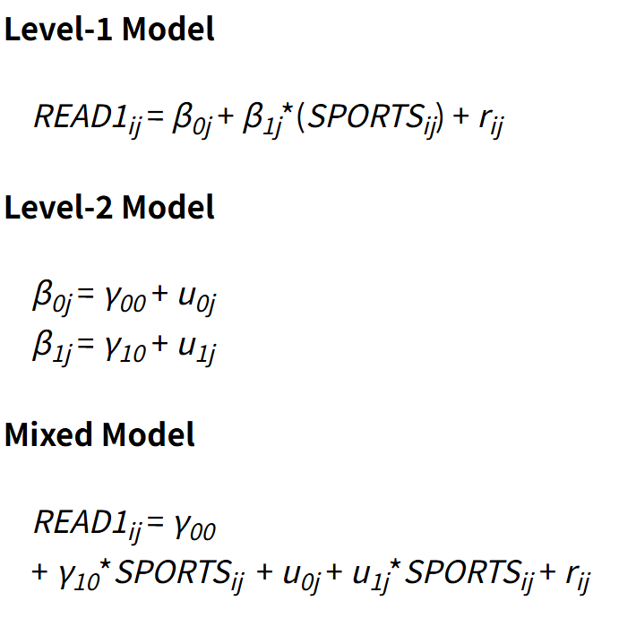
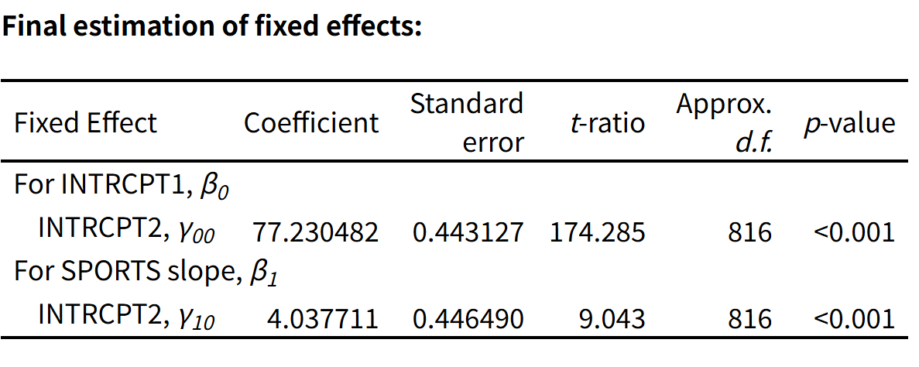

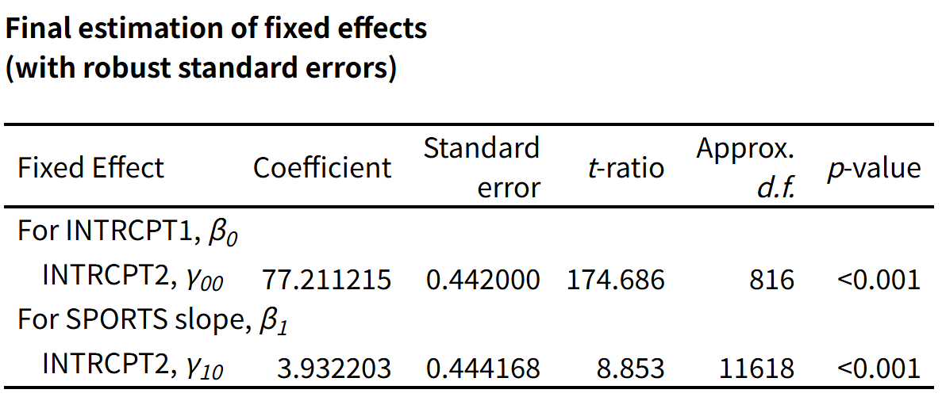

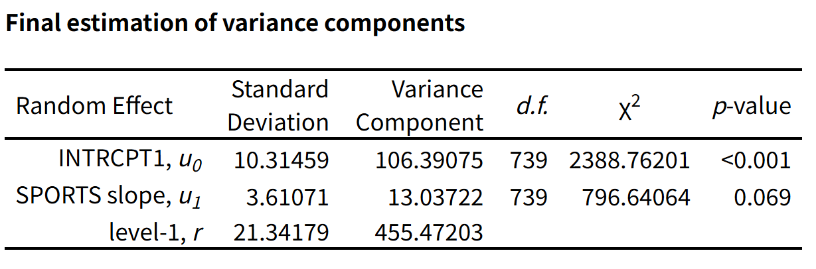

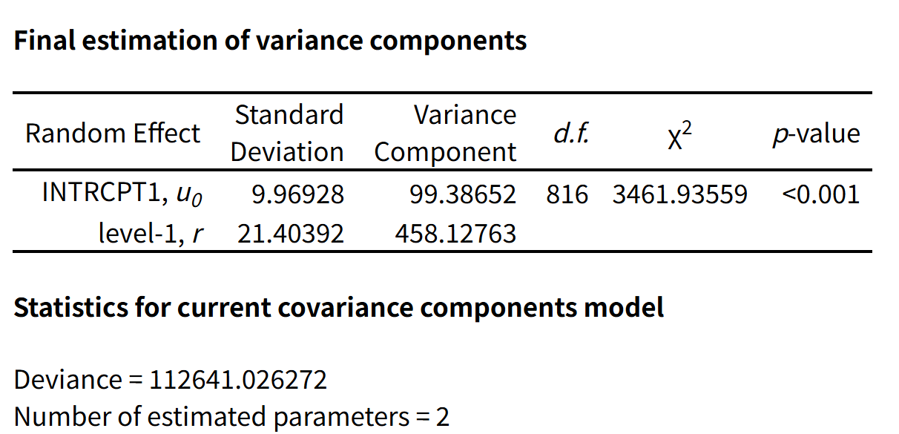

Random effects:
Component | Variance | SD
School intercept | 106.2 | 10.31
School Sports slope | 11.5 | 3.39
Residual | 455.7 | 21.35
In the naive random-slope HLM, the intercept was 77.23, which means the estimated average first-grade reading score for students who did not participate in organized sports in an average school. The Sports coefficient was 4.04 and statistically significant (p < .001), so students who participated in organized sports scored approximately 4.04 points higher on first-grade reading achievement than non-participants. There are a sizable positive association between sports participation and reading achievement in the unadjusted model.

The random intercept variance was statistically significant, with a school-level standard deviation of 10.31, showing that average reading achievement differed substantially across schools. In contrast, the random slope variance for Sports was positive but not statistically significant at the 0.05 level, although it approached significance. This provides only limited evidence that the association between sports participation and reading achievement varied across schools.

The naive model suggests that sports participants had higher first-grade reading scores than non-participants. However, because naive model did not adjust for student- or school-level covariates, the estimated sports advantage may be inflated by selection bias and should not be interpreted as a causal effect.

Model B: Covariate-Adjusted HLM

In the covariate-adjusted HLM, student-level covariates for gender, race, SES, arts participation, kindergarten reading achievement, and age is included. School-level covariates for Catholic school, other private school, and kindergarten enrollment, with public schools serving as the reference group are also included. The model included a random school intercept.

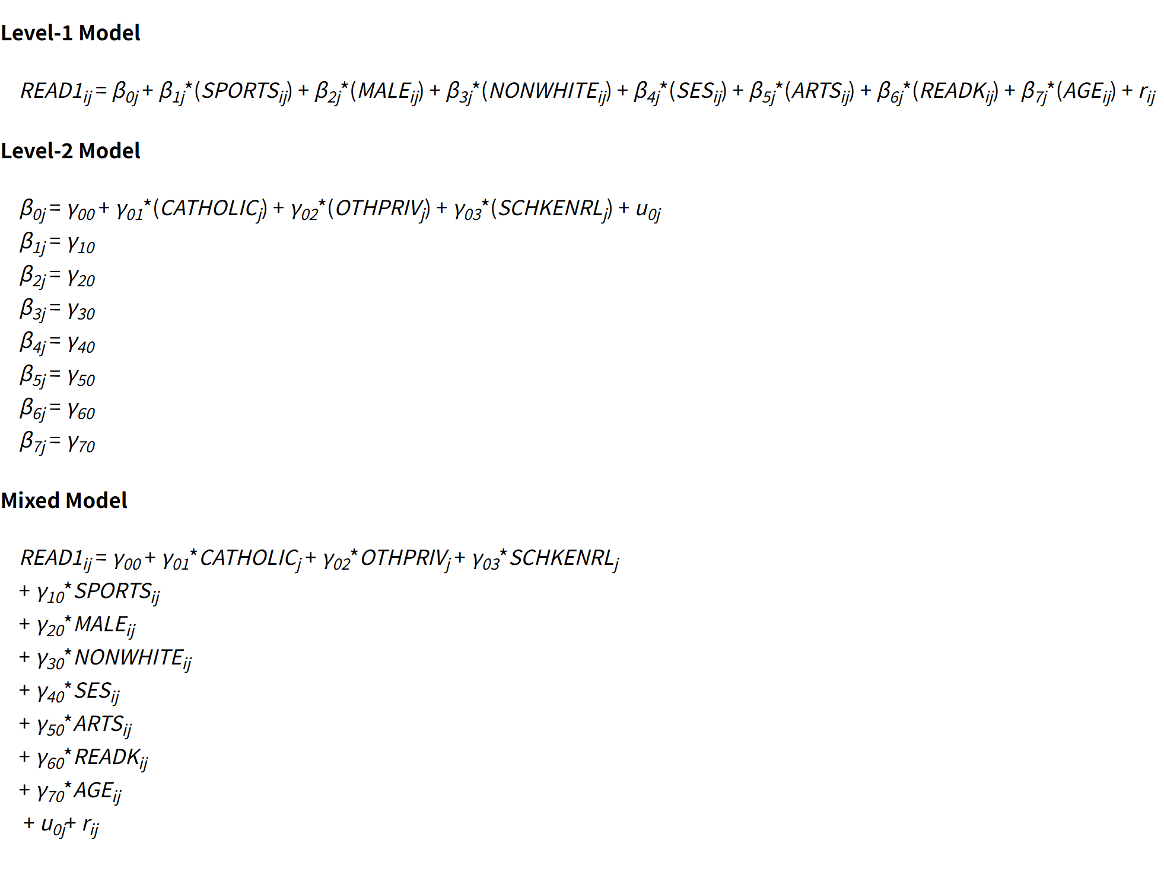

All student-level and school-level covariates are included with fixed slopes. Only the school intercept is random: (1 | S1_ID), to account for the nesting of students within schools.

Predictor | Estimate | SE | t | p
Sports | 1.00 | 0.30 | 3.28 | .001
Male | −1.15 | 0.27 | −4.31 | < .001
NonWhite | −1.02 | 0.32 | −3.14 | .002
SES | 2.53 | 0.21 | 12.21 | < .001
Arts | 1.07 | 0.39 | 2.75 | .006
ReadK | 1.23 | 0.01 | 118.91 | < .001
Age | −0.05 | 0.03 | −1.72 | .086
Catholic | −0.04 | 0.68 | −0.06 | .950
OthPriv | 1.03 | 0.75 | 1.37 | .170
SchKEnrl | −0.00 | 0.01 | −0.74 | .458

After adjusting for these observed covariates, the Sports coefficient decreased substantially from 4.04 in the naive model to 1.00 in the adjusted HLM (p = .001). Among students who were otherwise similar on the included student-level and school-level characteristics, those who participated in organized sports scored about one point higher on first-grade reading achievement than students who did not participate. Although the association remained statistically significant, the magnitude of the estimated treatment effect became much smaller after adjustment.

The large reduction in the Sports coefficient suggests that much of the naive association was due to observed confounding. In the unadjusted model, sports participants score more than 4 points higher than non-participants. However, students from higher-SES families and students with stronger kindergarten reading skills were likely both more likely to participate in organized sports and more likely to have higher first-grade reading scores for reasons unrelated to sports participation itself. Once these pre-existing differences were controlled, the estimated sports advantage declined, then the naive model overstated the association between sports participation and reading achievement.

The covariate-adjusted model showed that kindergarten reading achievement was the strongest predictor of first-grade reading achievement (b = 1.23, p < .001), indicating strong continuity in reading performance from kindergarten to first grade. SES was also positively associated with reading achievement (b = 2.53), and arts participation was associated with higher reading scores as well (b= 1.07). In contrast, male students and racial minority students scored lower on average after adjustment. School sector and kindergarten enrollment were not statistically significant once student-level covariates were included, then differences in reading achievement were explained more by student characteristics than by measured school-level factors.

II.Propensity Score Stratification
To estimate the sports–reading association within groups of students who have the same, or nearly the same, probability of sports participation.

- Propensity Score Model
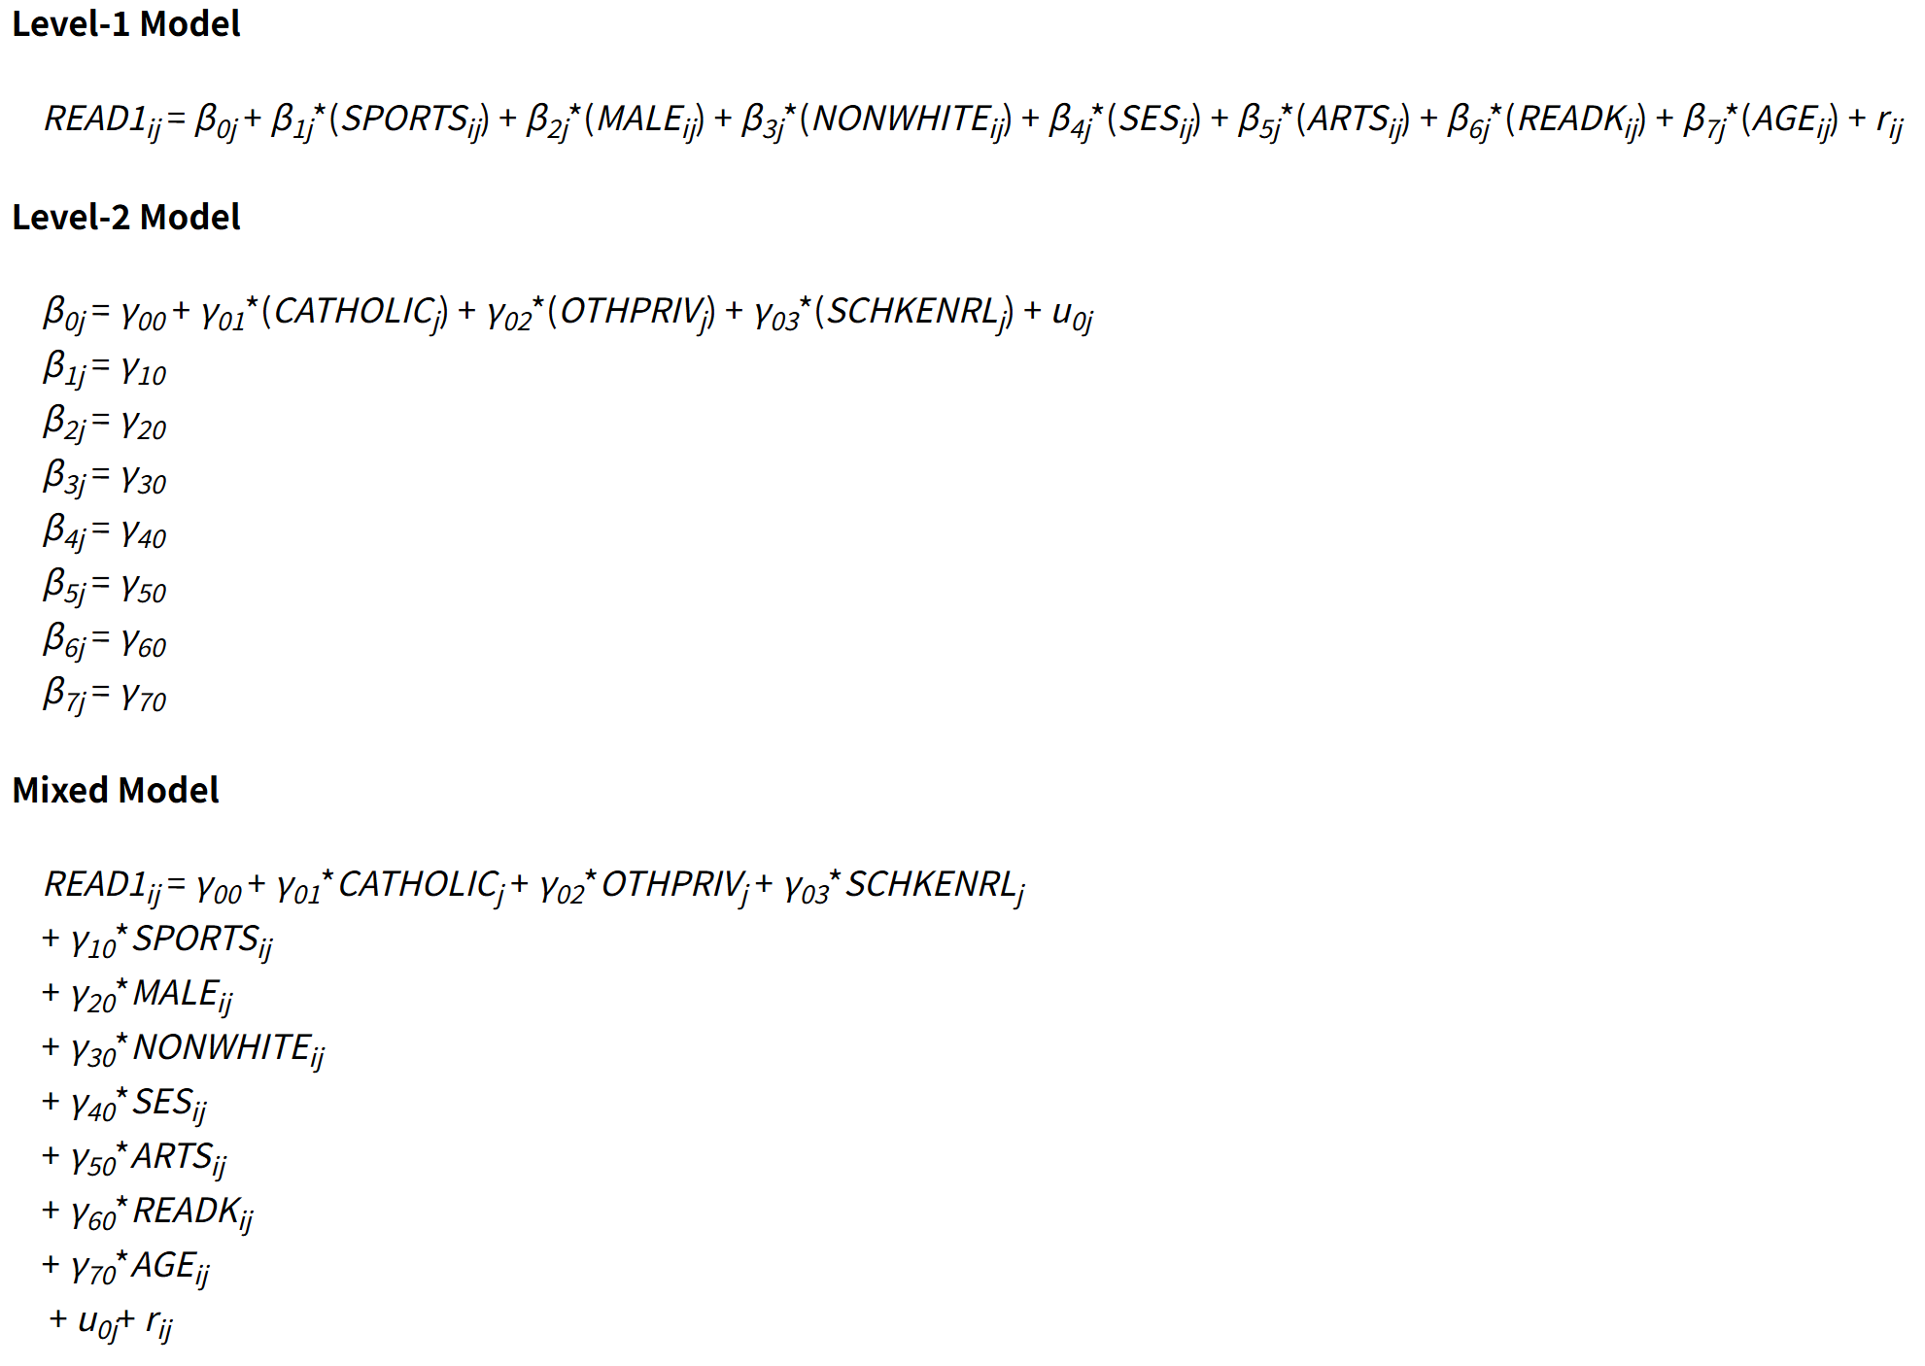

A two-level logistic regression model predicting Sports from all pre-treatment covariates, with a random intercept for school (S1_ID) is estimated. Predicted log odds of treatment (the linear predictor from the logistic model) were saved for each student and converted to propensity scores (predicted probabilities).

Selected fixed effects from the two-level logistic model
Predictor | Log-odds coefficient
Male | 0.93
NonWhite | −0.89
SES | 0.63
Arts | 0.25
ReadK | 0.006
Age | 0.023
Catholic | 0.37
OthPriv | −0.27
SchKEnrl | 0.0003 (n.s.)

Male, NonWhite, SES, Arts, ReadK, Age, Catholic, and OthPriv were predictors of sports participation. These results confirm that treatment is not random and justify propensity score adjustment.

B. Common Support
The distribution of propensity scores for treated (Sports = 1) and control (Sports = 0) students are examined. As shown in Figure 1, sports participants generally had higher propensity scores than nonparticipants, indicating that they were more likely to have observed characteristics associated with sports participation. However, the two groups also showed substantial overlap in their propensity score distributions, which supports the use of propensity score stratification.
To ensure common support, sample to students with propensity scores are restricted between 0.05 and 0.95. It removed 48 students(0.4% of the original sample), leaving 12,388 students for the stratified analysis. Establishing common support is necessary because treated and control students with extremely low or high propensity scores may not have comparable counterparts in the other group. For example, some students with high probabilities of sports participation may have no similar nonparticipants for comparison, and vice versa. Estimating treatment effects in these regions would require extrapolation and could produce biased results. By restricting the analysis to the region of overlap, the propensity score stratification compares students who had similar probabilities of participating in organized sports, making the treatment and control groups more comparable.

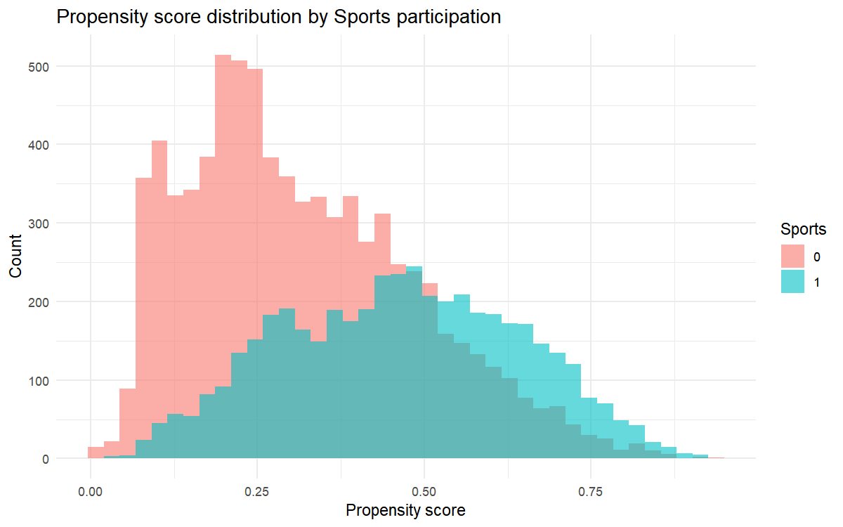

(Figure shows that sports participants tended to have higher propensity scores than nonparticipants, but there was substantial overlap between the two groups. This overlap supports the use of propensity score stratification.)

C. Stratification
Students in the common-support sample were sorted by propensity score and divided into five equal-sized strata using quintiles. Stratum sizes were approximately 2477–2478 students per stratum. Stratum 1 served as the reference category in the final model; strata 2–5 were entered as dummy indicators (strata2–strata5).

D. Balance Diagnostics
I assessed balance between treated and control students using absolute standardized mean differences (|SMD|) on all covariates, both overall and within each stratum.

Balance diagnostics after propensity score stratification
Balance criterion | Result
Within-stratum SMDs below 0.10 | 80.0%
Within-stratum SMDs below 0.20 | 88.9%

After stratification, 80.0% of within-stratum comparisons had |SMD| below 0.10 and 88.9% below 0.20, good balance by conventional standards (|SMD| < 0.10 is ideal; |SMD| < 0.20 is acceptable). Within each stratum, treated and control students were much more similar on observed covariates than in the full sample. Improved balance reduces bias from observed confounding, although it does not eliminate bias from unmeasured confounders.

E. Final Analytic Model HLM
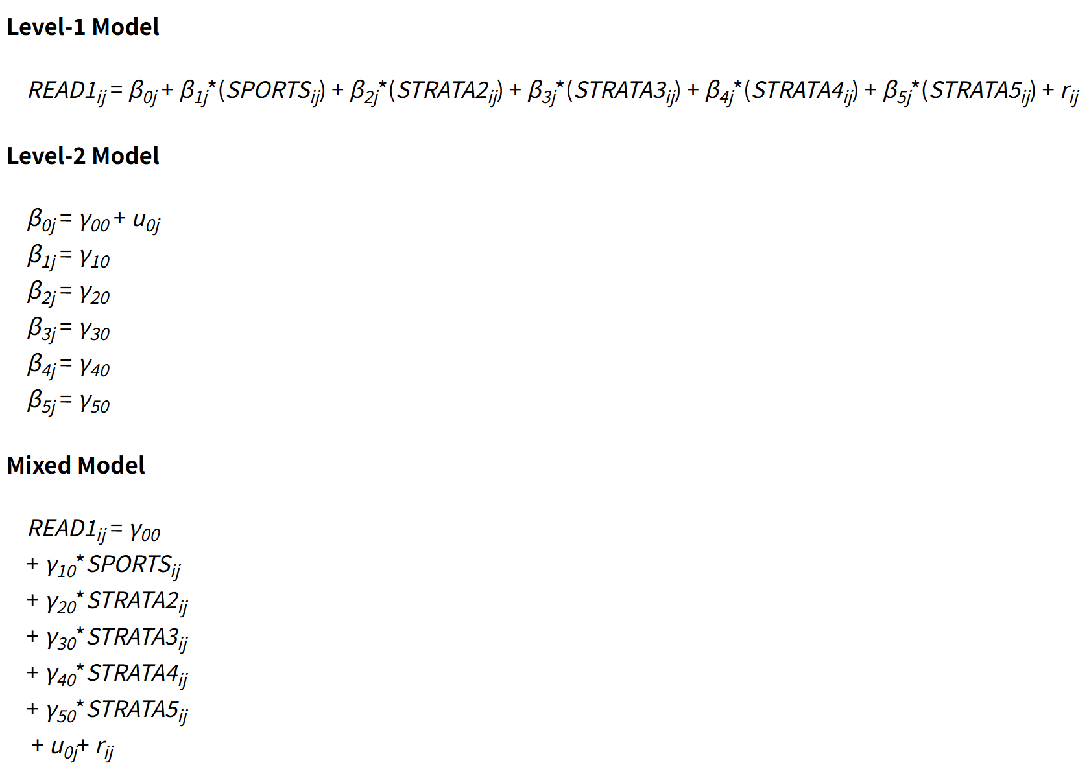

The final propensity score stratified HLM was estimated in HLM 7 using the PS-stratified Level-1 file linked to schools by S1_ID. The model included sports participation and five propensity score strata as Level-1 predictors, with a random school intercept to account for the nesting of students within schools. The intercept represents the expected first-grade reading score for nonparticipants in the reference propensity score stratum, while the Sports coefficient estimates the difference in reading achievement between sports participants and comparable nonparticipants within propensity score strata.

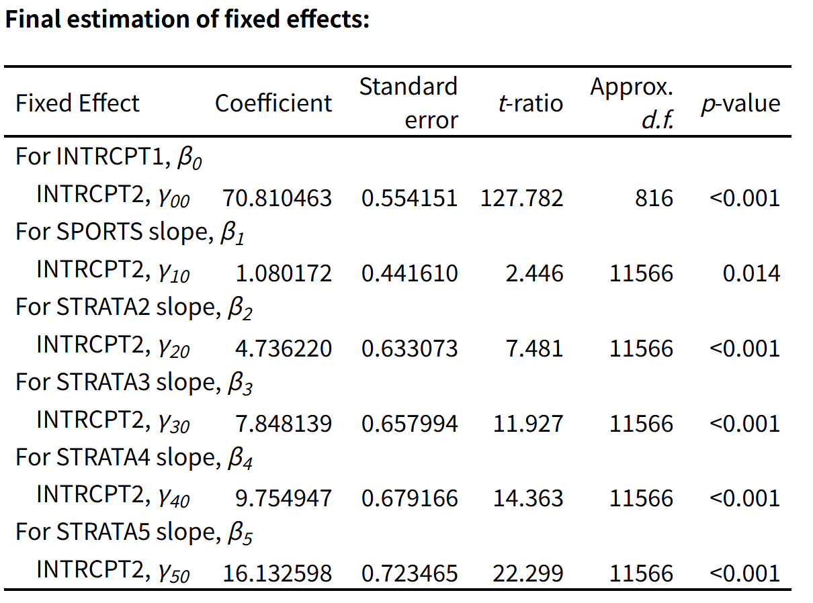
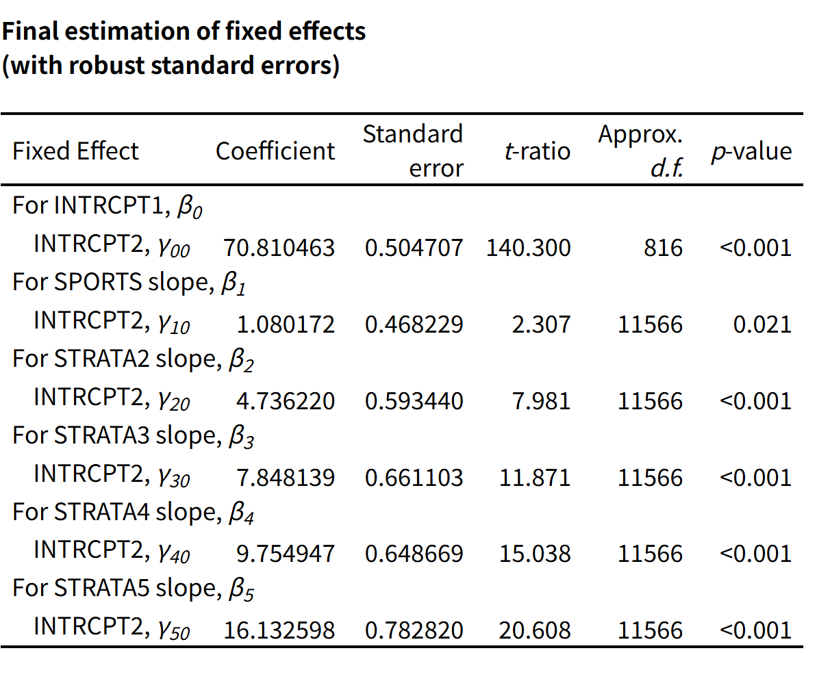
In the final stratified HLM, the Sports coefficient was 1.08 and statistically significant (p = .014). Within propensity score strata, students who participated in organized sports scored approximately 1.08 points higher on first-grade reading achievement than comparable students who did not participate. This estimate is much smaller than the naive estimate of 4.04 and close to the covariate-adjusted estimate of approximately 0.97–1.00. This pattern suggests that most of the raw difference in reading achievement between sports participants and nonparticipants was due to selection on observed characteristics rather than sports participation itself.
The propensity score stratum coefficients were also statistically significant and increased across higher strata. This indicates that students in higher propensity score strata had higher average reading scores than students in the reference stratum. This result is expected, as students with higher probabilities of participating in sports also tended to have characteristics associated with stronger reading achievement, such as higher SES and stronger kindergarten reading scores.
Sports participation remained positively associated with first-grade reading achievement after propensity score stratification, but the estimated effect was much smaller than in the naive model. This suggests a modest positive association between organized sports participation and reading achievement, and it indicates that much of the original unadjusted difference was likely due to selection on observed characteristics.

The final HLM included sports participation and propensity score strata, with a random school intercept. In it, sports coefficient was 1.08, within propensity score strata, sports participants scored about 1.08 hogher on first grade reading achievement than comparable nonparticipants. The association was significant using robust standard errors.

Model specification sensitivity (comparison across approaches)

Model | Sports coefficient | SE | t | 95% CI
Naive HLM | 4.04 | 0.44 | 9.10 | [3.17, 4.91]
Covariate-adjusted HLM | 1.00 | 0.30 | 3.28 | [0.38, 1.56]
PS-stratified HLM | 1.08 | 0.47 | 2.31 | [0.22, 1.95]
PS-stratified + adjusted HLM | 0.96 | 0.30 | 3.24 | [0.38, 1.54]

The three adjusted estimates (1.00, 1.08, and 0.96) are similar, suggesting that the conclusion of a small positive association is moderately robust to model specification. The large difference between the naive and adjusted estimates confirms that confounding was substantively important.

F. Causal Interpretation
A causal interpretation of the sports effect would require several assumptions: all variables that affect both sports participation and reading are observed and correctly modeled, there is no unmeasured confounding all variables; common support, treated and control units have overlapping propensity scores; correct model specification; and stable unit treatment value (SUTVA), one student's sports participation does not affect another student's reading.

Common support and balance on observed covariates appear reasonable, so bias from observed confounding is likely reduced. However, the no-unmeasured-confounding assumption has questions. Factors such as parental involvement, student motivation, neighborhood resources, health, and school encouragement of extracurricular activities affect both sports participation and reading but were not measured. Reverse causality is also possible, because students with stronger academic performance may have been more likely to participate in sports. Therefore, the findings should be interpreted as evidence of an association rather than definitive proof of a causal effect.

Sensitivity Analysis

I evaluated whether the estimated sports effect is robust to potential unobserved confounding. Kindergarten reading (ReadK) selected as a powerful predictor of the outcome (b = 1.23 in the adjusted outcome model) and computed the mean difference in ReadK between sports participants and non-participants (Δ = 3.55 points). The estimated plausible bias from an unobserved confounder as strong as ReadK is: Plausible bias = |bReadK| × |ΔReadK| = 1.23 × 3.55 ≈ 4.37

The PS-stratified sports coefficient (1.08) and covariate-adjusted coefficient (0.97) are smaller than this plausible bias (4.37). If an unobserved confounder as strongly related to reading as kindergarten reading score were omitted from the model, it could explain the remaining estimated sports effect. The naive estimate (4.04) is close to this benchmark, so many raw connection was confounding. Thus, the small adjusted effects are not robust to unobserved confounding of ReadK-like strength, and causal claims are not likely to explain all scenes.

III Conclusion
After adding student- and school-level covariates, the sports coefficient decreased from 4.04 in the naive model to 1.00 in the adjusted HLM. After controlling for observed covariates, students who participated in organized sports scored about 1 point higher in first-grade reading than students who did not participate. The association remained statistically significant(p = .001).

The propensity score stratified HLM also supported a small positive association between sports participation and first-grade reading achievement. Across the adjusted models, the estimated sports effect was about one point, much smaller than the naive estimate.

Across model specifications, the estimated Sports coefficient was 4.04 in the naive model, 0.97–1.00 in the covariate-adjusted model, 1.08 in the propensity score stratified model, and 0.96 in the propensity score stratified plus covariate-adjusted model. The three adjusted estimates were very similar, suggesting that the conclusion of a small positive association between sports participation and reading achievement is moderately robust to model specification. At the same time, the large difference between the naive and adjusted estimates indicates that confounding was important and that the naive model likely overstated the association.

Sports participation was positively associated with first-grade reading achievement. The naive HLM suggested a four-point advantage for sports participants, but this estimate fell to about one point after covariate adjustment and propensity score stratification. This pattern indicates that much of the raw difference in reading achievement reflected pre-existing differences between students rather than sports participation.

Covariance adjustment and propensity score stratification addressed observed selection in different ways. Covariance adjustment directly controlled for observed confounders in the outcome model and was straightforward to implement in the HLM framework. Its main advantage is efficiency because it uses the full sample and provides interpretable coefficients for the included covariates. However, it depends heavily on correct specification of the outcome model and does not explicitly assess balance between treated and control students.

Propensity score stratification improved comparability by grouping students with similar probabilities of participating in sports and evaluating covariate balance within strata using standardized mean differences. Its main advantage is that it makes the selection process more transparent and provides direct evidence about whether treated and control students are comparable on observed covariates. Its limitations include possible sample loss from common-support trimming, reliance on correct specification of the propensity score model, and the need to include strata in the final outcome model.

Together, both methods led to the same substantive conclusion, after accounting for observed differences between students, sports participation was associated with a small but significant increase in first-grade reading achievement. However, this result should still be interpreted cautiously. A causal interpretation would require assumptions such as no unobserved confounding, common support, and correct model specification. Because unmeasured factors such as parental involvement, student motivation may still affect both sports participation and reading achievement, the findings should be interpreted as evidence of an association rather than definitive evidence of a causal effect.

